Interpretation of the Correlation Matrix: Nigerian Advertising Campaigns
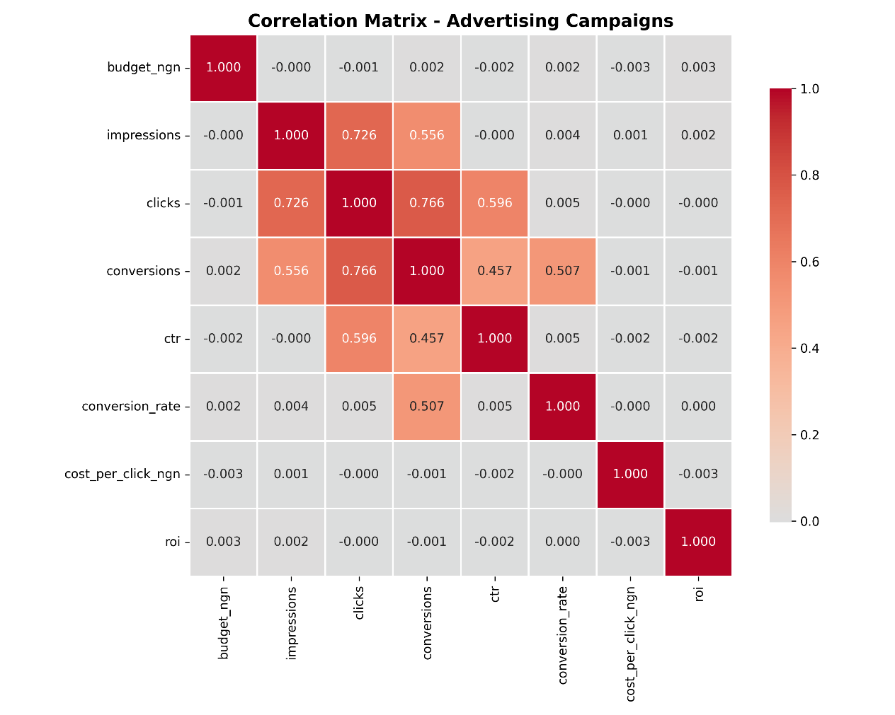
(Reference correlation heatmap)
Abstract
This study analyses the correlation structure among key performance indicators (KPIs) in Nigerian advertising campaigns, including budget allocation, impressions, clicks, conversions, click-through rate (CTR), conversion rate, cost per click (CPC), and return on investment (ROI). The objective is to identify statistically meaningful relationships within the marketing funnel and determine whether financial inputs directly influence profitability outcomes. The findings reveal a structurally coherent acquisition funnel but a weak association between spending metrics and profitability, indicating that efficiency—not scale—is the primary performance driver.
Introduction
Digital advertising performance is typically evaluated through a sequence of interrelated metrics that reflect audience reach, engagement, and conversion behavior. Understanding the interdependence among these variables is essential for optimizing strategic allocation decisions. Correlation analysis provides insight into the strength and direction of linear relationships among these KPIs. This interpretation evaluates whether campaign spending, engagement metrics, and efficiency indicators collectively influence conversion outcomes and financial returns.
Funnel Dynamics
The correlation matrix reveals strong positive relationships within the core acquisition funnel. Impressions are strongly correlated with clicks (r = 0.726), indicating that increased exposure reliably generates user engagement. Clicks, in turn, show a strong correlation with conversions (r = 0.766), confirming that higher engagement levels translate into measurable outcomes. Additionally, impressions are moderately correlated with conversions (r = 0.556), reinforcing the indirect but meaningful effect of reach on final actions.
These results confirm the structural integrity of the marketing funnel: awareness drives engagement, and engagement drives conversion. The statistical strength of these relationships suggests operational consistency in campaign execution.
Engagement and Efficiency Metrics
Clicks demonstrate a moderate positive relationship with CTR (r = 0.596), which is expected since CTR is partially derived from click activity relative to impressions. Conversions also show moderate correlation with conversion rate (r = 0.507) and CTR (r = 0.457), indicating that engagement quality contributes to improved conversion outcomes.
However, CTR shows negligible correlation with conversion rate (approximately r = 0.005), implying that higher engagement does not necessarily translate into proportional improvements in conversion efficiency. This suggests potential weaknesses in post-click processes such as landing page optimization, offer relevance, or audience qualification.
Budget and Cost Variables
A notable finding is the near-zero correlation between budget and all major performance indicators, including impressions, clicks, conversions, CTR, conversion rate, CPC, and ROI. This indicates that higher spending levels do not inherently produce better performance outcomes.
Similarly, CPC exhibits negligible correlation with conversions and ROI. Lower click costs do not appear to guarantee improved profitability or conversion volume within this dataset.
These findings challenge the assumption that financial scale alone drives campaign success. Instead, they highlight the importance of allocation efficiency and targeting precision.
Profitability (ROI)
ROI shows near-zero correlation with traffic, engagement, cost, and efficiency metrics. This suggests that profitability is influenced by additional variables not captured within the dataset, such as revenue per conversion, customer lifetime value, or fixed operational costs.
The absence of strong linear relationships between ROI and other KPIs indicates that revenue dynamics may operate independently from traffic acquisition patterns.
Discussion
The correlation structure demonstrates that campaign mechanics function effectively at the acquisition level. The sequential dependencies—impressions to clicks to conversions—are statistically strong and logically aligned with established marketing theory.
However, financial and efficiency metrics do not show meaningful direct relationships with ROI. This disconnect implies that while campaigns succeed in driving user actions, they may not consistently optimize economic value. The weak relationship between CTR and conversion rate further suggests that engagement quality may not be fully aligned with purchase intent.
From a strategic perspective, these findings emphasize that scaling exposure without refining targeting or post-click optimization may increase volume but not profitability. Efficiency improvements in landing page performance, audience segmentation, and revenue modeling are likely to yield stronger financial gains than increased ad spend alone.
Conclusion
The analysis confirms a statistically robust and operationally sound marketing funnel within Nigerian advertising campaigns. Engagement and conversion metrics exhibit strong interdependence, validating the structural integrity of campaign execution. However, budget allocation and cost efficiency metrics demonstrate negligible influence on ROI, indicating that financial performance is not solely determined by traffic volume or click costs.
Overall, the evidence suggests that performance optimization should prioritize qualitative improvements in targeting, user experience, and revenue extraction rather than quantitative expansion of advertising spend. Future research should incorporate revenue-per-conversion data and customer lifetime value metrics to better explain profitability variation.

